
EXCEL ACTIVITY 31
I am in charge of the whole store! HELP!
Rebel Alliance Store

R2-D2, who will be in charge of the store, must order supplies that will be available for purchase. The residents of Naboo have voted to donate a percentage of the store’s profits to charity (Tatoonie Relief), so the goal is to generate as much profit as possible. R2-D2 will be ordering supplies from McMurphy’s Office Supply Catalog. These are the choices offered by McMurphy’s, from which R2 will select up to 10 items for sale in the store. (DO NOT just type this list. Select 10 items only from the list – do not enter anything into a spreadsheet yet.)
The Rebel Alliance is setting up a new store on the planet of Naboo. You will use the spreadsheet as a decision making tool in this activity. You will use various features of the spreadsheet as you set up the store. You will use the spreadsheet to speculate the profit that will be generated from various selling prices of items.
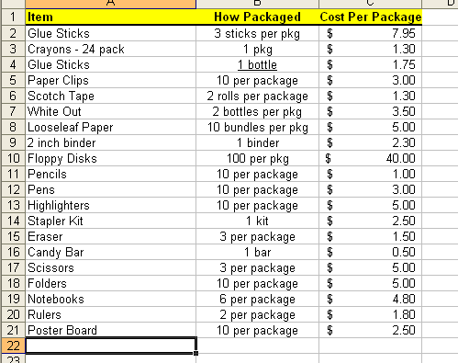

1. R2-D2 must figure out the cost of each of the items available from McMurphy’s Catalog.
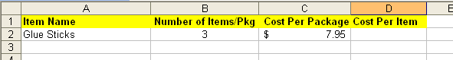
Set up a spreadsheet for this purpose. Format so that it looks like the one below:
  - Remember to format Columns C and D for Currency.
  - You will need to widen most of the columns to fit.
  - You will need to enter the actual number of items in each package in Column B.
2. Add the rest of your ten items to the spreadsheet, as well as the rest of Columns B and C. Column D will remain empty for now.

3. Use a formula in Cell D2 to compute the cost of the first item. You want to know how much an individual glue stick will cost. This will be a division problem. Type your formula into Cell D2.

4. Use the Fill Down feature to copy the formula to the other cells in Column D.

5. If you haven’t already done so, Go to Page Set-up and format this spreadsheet for landscape mode, gridlines & headers showing, and put your name and Activity 31 in a footer. Save as Activity 31.
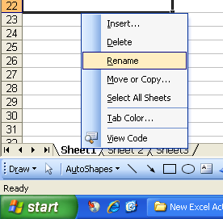
6. You are currently working on Worksheet 1. In this Activity you are going to use two different worksheets. Let’s rename them from Worksheet 1 and 2. Right Click on the Worksheet 1 tab at the bottom of the spreadsheet. From the menu that appears, click on Rename. Type <Cost Per Item> as your new Sheet title. Click on Sheet 2. Rename it to <Store Profits>. Save again.
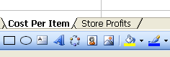

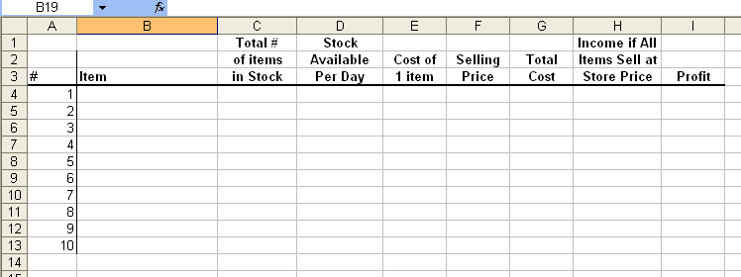
7. Click on Worksheet 2 (Store Profits). Set up ANOTHER spreadsheet to look like the one below:

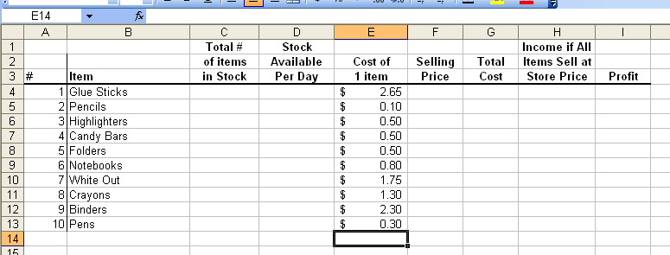
8. Fill in Columns B and E using the information on Sheet 1 (Cost per Item) You can copy and paste the items, but you will have to transfer the Price per item by hand.

9. R2D2 will be ordering enough stock for one semester of sales. There are 50 days in a semester. 500 rebels live in this Naboo community. The store is only open during the noon lunch hour (hey, R2D2 has more important things to be doing than managing a store!)

10. You will help R2D2 decide how many of each item you want to purchase. Enter these numbers into Column C on Worksheet 2 (Store Profits). Experiment with numbers in Column C until you are satisfied with your purchases. Remember you want to order enough to last through the 50 days.

11. You obviously want to make a profit on each item that is sold. To do this, you must mark up the selling price of each item. The percent of markup may be different for each item. It is up to you and R2 to decide the best price for each supply. Supplies that are priced too high will not sell. Supplies priced too low will not generate as much profit as they could. You will need to type formulas into column F that represent the actual cost plus the percent markup for each item. Depending on the markup you decide upon, your formulas will look like this:
Why does the 100% formula contain 2.00, when the markup says 100? Because the first 1.00 percent is the original cost of the item. The second 1.00 is the markup, for a total of 2.00.
Candy Bars
Markup | Cost | Formula
10% | $ 0.55 | =0.5*1.10
25% | $ 0.62 | =0.5*1.25
50% | $ 0.75 | =0.5*1.50
100% | $ 1.00 | =0.5*2.00

12. Click on cell G4. Build a formula that shows the Total Cost for each item. Use cell locations to build this formula. The formula should multiply the number of items ordered by the cost per item. (Column C times Column E.)

13. Click on cell H4. Build a formula that shows how much money would be generated if EVERY item in the school store sold at the selling price. Use cell locations to build this formula. Fill this formula down through Cell H13. (HINT: Total number of items times the selling price.)

14. Click cell G14. Use the SUM formula to calculate the Total Cost of ALL the products.

15. Click cell H14. Use the SUM formula to calculate the Total Profit from the products if everything sold.

16. Click cell I14. Use a formula to figure out how much money the Naboo store will be able to send to the Tatoomie Relief Agency. Bold and highlight this answer. (HINT: this will be a subtraction problem!)

FINISHING:
- Make sure you have a footer with your name and Activity 31.
- Make sure you are in landscape mode.
- Check your worksheet with the sample in the back.
- Submit through Edmodo or as directed by teacher.
.

THANK YOU SO MUCH FOR YOUR HELP IN SETTING UP OUR STORE ON NABOO.



TATOONIE Relief thanks you too!


