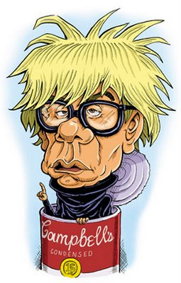
Andy Warhol
Multiple Print “Silkscreens”
Project Directions w/ Optional Modifications

MATERIALS: 2 pieces of 5 ¾” x 9” white drawing paper; Sharpies; thick Black marker; tissue paper; glue stick; scissors. Modified: 4 pieces paper, crayons/colored pencils
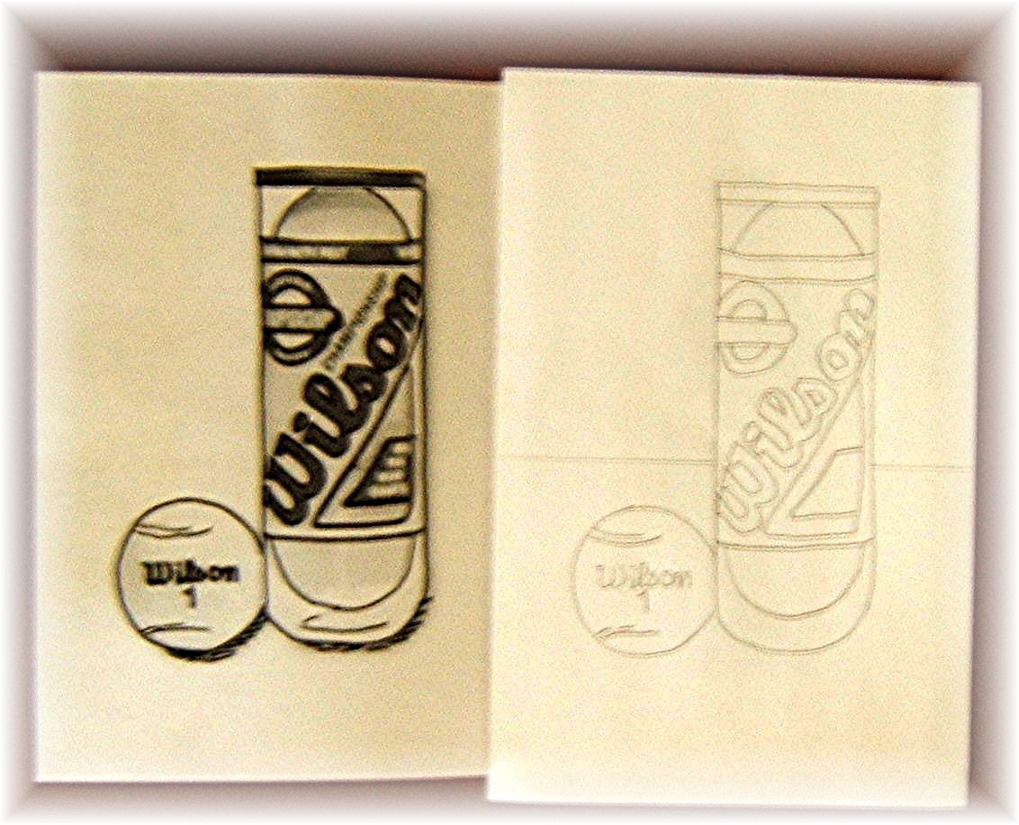
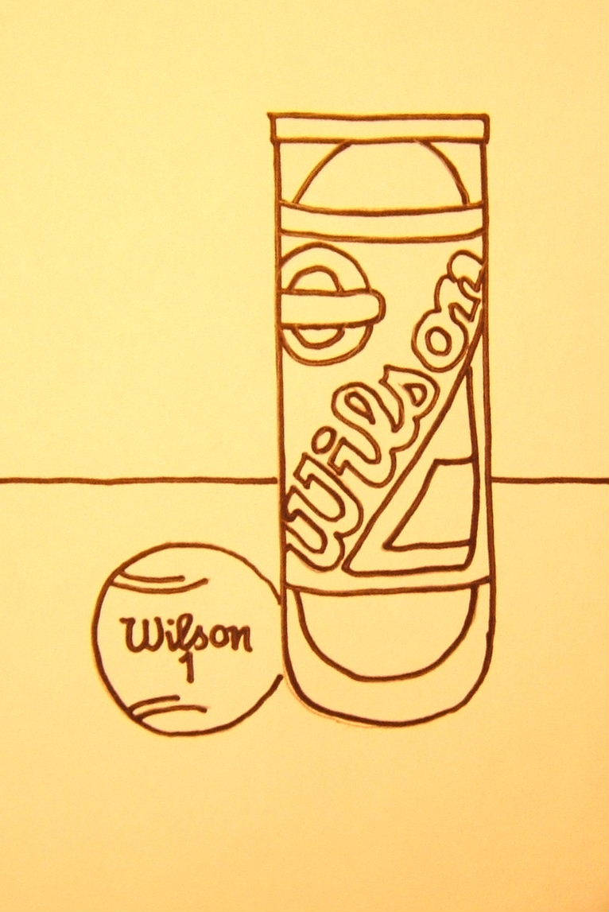
1. Select or draw an image of a common, everyday item or object. This image must fit within a 5 ¾” x 9” panel. Go over the main lines of the image with a Black Sharpie. Don’t put in too much detail, but enough that the viewer will be able to identify the object.

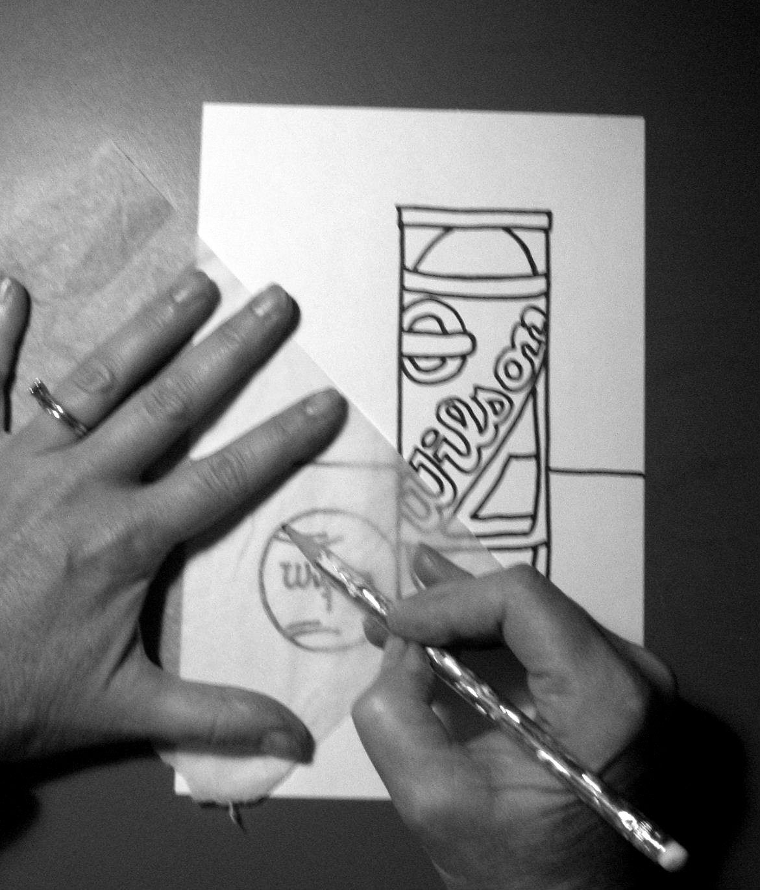
2. Go to a light table and trace the Sharpie lines with pencil two times on two separate pieces of the pre-cut paper. Make sure the image is located in the same place each time. To make the project easier, you can go over the pencil lines with a Black Sharpie. You may have to repeat this tracing again at the end.

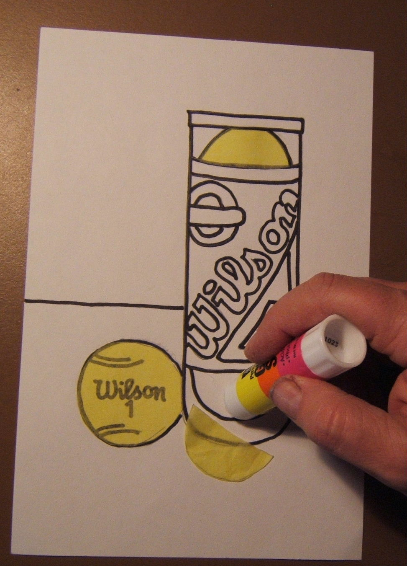
3. Select four colors of tissue paper. Warhol didn’t use a wide variety of colors in his multi image prints. You will “color” in each image by laying the tissue on top, tracing lightly with pencil the shape of the image, cutting out the tissue, and gluing it in place. Each one of the panels should be colored differently, but still using JUST the four colors. Realistic colors are NOT important! If you have re-outlined the image in Sharpie, it will be easy to see through the tissue to trace, especially the darker tissue colors.

4. To glue the tissue in place, rub glue stick into the image space and carefully place your tissue on top. Use your hand to carefully press down so the tissue is glued completely. Do NOT try to spread the glue on the back of the tissue paper.

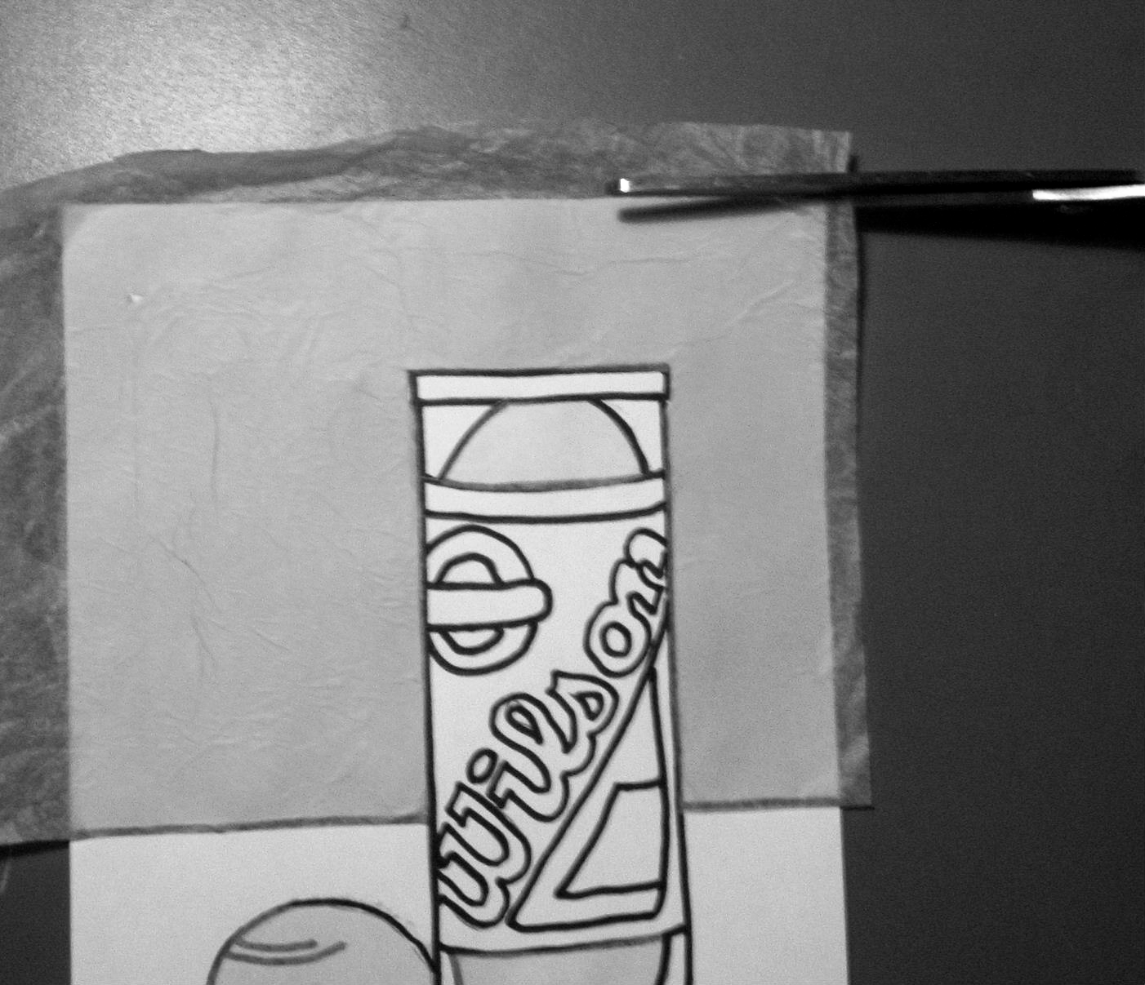
5. When both panels are tissue colored, go back over the lines carefully with the Sharpie. In a true Warhol silkscreen, these lines would be printed on (as would all the colors).

6. Trim all edges even with the edge of the paper. Sign ONE of the images in the lower corner with a black extra fine tip Sharpie.

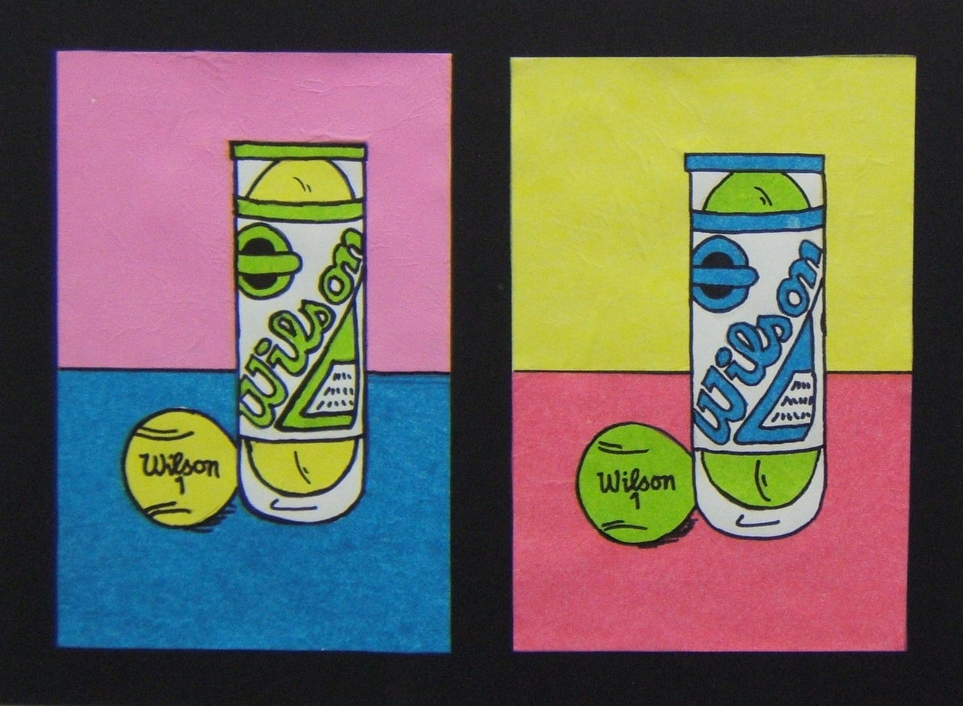
7. MOUNTING: Get a piece of black tagboard 11” x 14” from behind the paper cutter. You will staple your two images, evenly spaced, on the black background, using 4 staples in each corner.
8. Complete a grading sheet. Place grading sheet on top of project and place both in the project in-box.

Modified Directions: (Worth 20 points maximum rather than 25 pts.)
If you are tissue paper and/or glue challenged (or lose your right to use glue!)…..
1. Follow steps 1-2 with this change – you will need 4 pieces of paper and 4 completed drawings, outlined in Sharpie, of your Pop object.

2. Select four colors. These are the only colors, besides white, that you can use. You may use crayons or colored pencils. Color the first object using the four colors, plus white (limited amount of white space). The background must also be colored.

3. Color the second paper, shifting the colors to a new location. You will have to plan carefully so you can shift the colors each time and all four papers will come out with the colors always different and never in the same place twice.

4. Complete steps 5-8, except you will not need to trim the edges, plus you will use a 14 ½” by 20 ½” piece of black paper to mount similar to Mrs. Rembold’s tennis shoe sample on the wall.

